1. Use the online API testing tool ReqRes (https://reqres.in/) to make a GET request to /api/users/2 and note down the response status code and the returned user's first name.
Ans:
For the ReqRes API request:
GET: https://reqres.in/api/users/2
The expected result is:
Field | Result
Response Status Code | 200 OK
User First Name | Janet
So, the answer is: Status Code = 200, First Name = Janet.

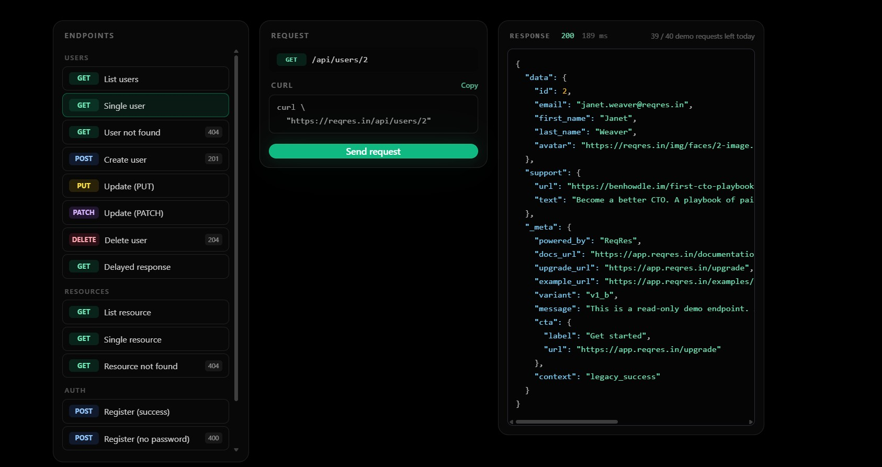

2. Send a POST request using ReqRes to /api/users with JSON data {"name": "Virat", "job": "Cricketer"} and write down the response code and the id value returned in the response.
Ans:
For the ReqRes POST request:
POST: https://reqres.in/api/users
JSON Body:
Field | Result
Response Code | 201 Created
id | Dynamically generated by ReqRes
The 201 status indicates that the user was successfully created. The returned id is generated dynamically, so it can vary with each request and should be copied from the actual response.

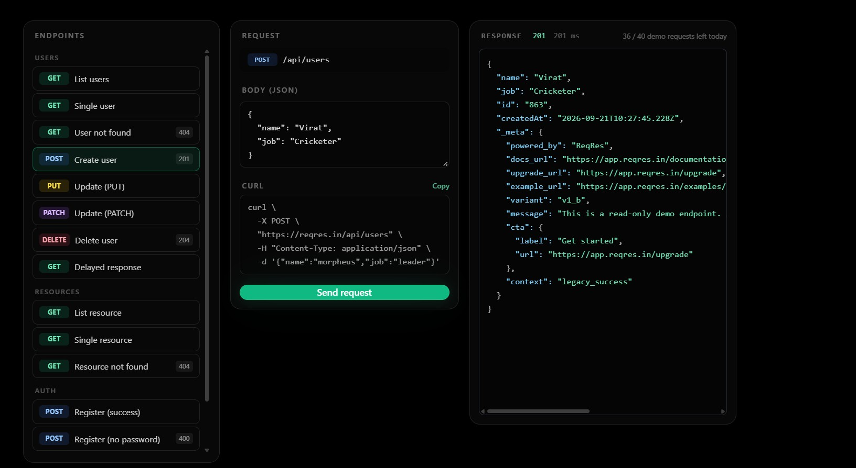

3. Given the following JSON response from an API: {"id": 101, "name": "Pizza Hut", "location": "Ahmedabad"}, write the SQL INSERT statement to add this restaurant to a table named restaurants with columns id, name, and location.
Ans:
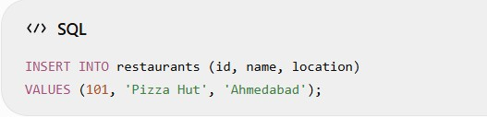

4. Suppose you have a users table in your database and the UI shows a new user 'Riya' was registered. Write an SQL SELECT query to confirm if 'Riya' exists in the users table, and explain what result you would expect if the UI and DB are in sync.
Ans:
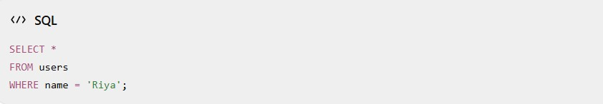
Expected result:
If the UI and database are in sync, the query should return a record for Riya in the users table.
For example:
id | name | email
102 | Riya | riya@example.com
If no row is returned, it indicates that Riya is not present in the database, so the UI and DB may not be synchronized.

5. After deleting a product from your shopping cart in the Flipkart UI, write an SQL query to verify that the product is no longer present in the cart_items table for your user.<br><br><em><strong>Hint:</strong> Use SELECT to check for the product_id and your user_id in cart_items.</em>
Ans:
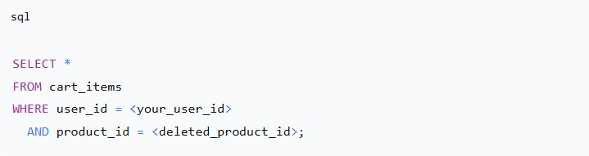
Or, to just count matching rows:
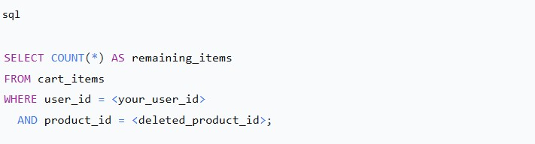
Expected result after successful deletion:
- The SELECT * query should return 0 rows.
- The COUNT(*) query should return 0.
If it returns one or more rows, the product is still present in the cart for that user, meaning the deletion may not have been saved or the UI may be out of sync with the database.
Example:
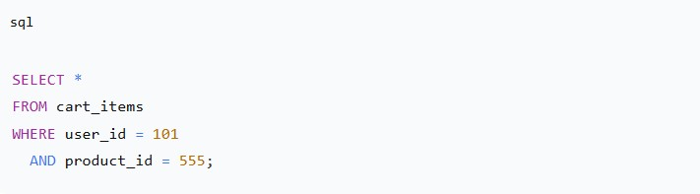
If this returns no rows, the product 555 has been successfully removed from user 101’s cart.

